**Ideation Phase**

**Define the Problem Statements**

|  |  |
| --- | --- |
| Date | 31 January 2025 |
| Team ID | LTVIP2025TMID55946 |
| Project Name | Docspot |
| Maximum Marks | 2 Marks |

**Customer Problem Statement Template:**

Patients face delays, frustration, and confusion when trying to book or manage healthcare appointments due to outdated, non-intuitive, and fragmented booking systems. They need a simple, secure, and real-time solution to schedule, reschedule, and access appointments—without long wait times, manual processes, or privacy concerns.

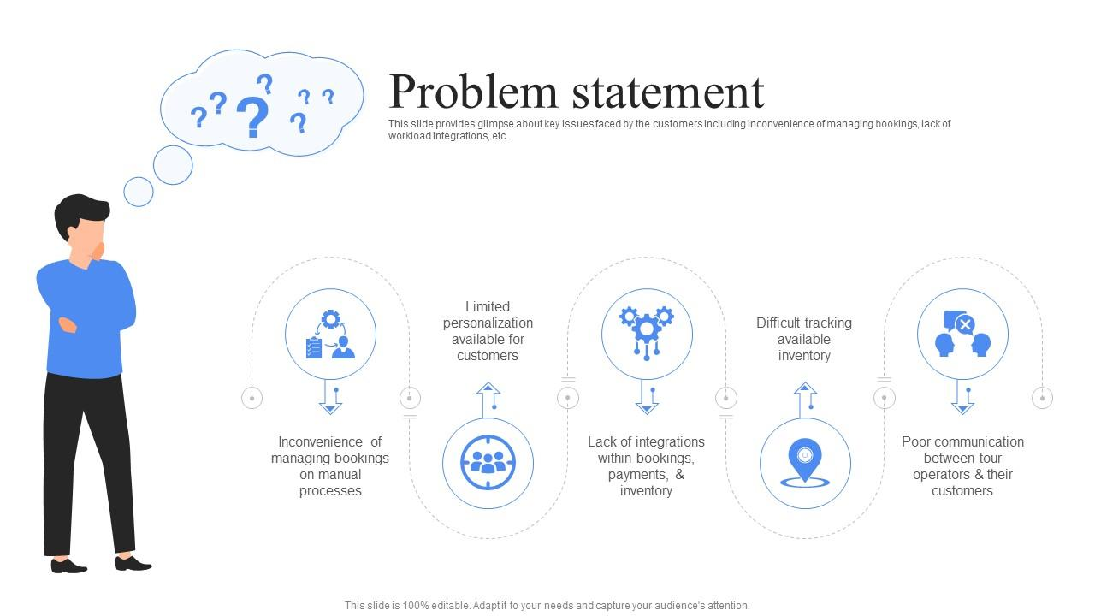

Reference: <https://miro.com/templates/customer-problem-statement/>